Program 1:
Demonstrate all the text formatting tags in a single HTML page.
Source code:
<!doctype html>
<html lang="en">
<head>
<meta charset="UTF-8" />
<meta name="viewport" content="width=device-width, initial-scale=1.0" />
<title>Lab Manual Program-1</title>
</head>
<body>
<div>
<strong>bold</strong> <br />
<i>italic</i> <br />
<u>underline</u><br />
<big>Big Tag</big><br />
<small>Small Tag</small>
</div> <div>
subscript H<sub>2</sub>O <br />
superscript E = mc<sup>2</sup>
</div>
<div>highlighted text : <mark> this is highlighted text </mark></div>
<div> inserted text : <ins> this text is inserted </ins> <br />
deleted text :<del> this text is deleted </del>
</div> <div>
code tag : <code>button</code><br />
keyboard Tag : <kbd> Ctrl + C </kbd>
</div>
</body>
</html>
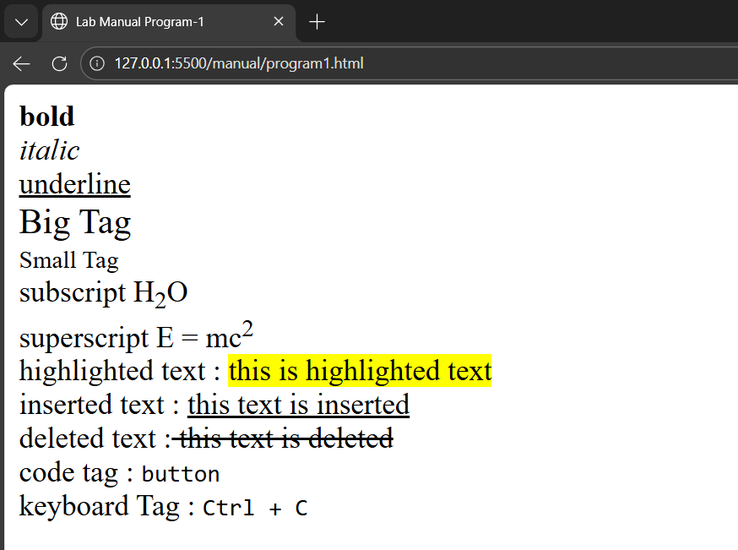
Output:

Program 2:
Write a HTML code to draw the following Figure :
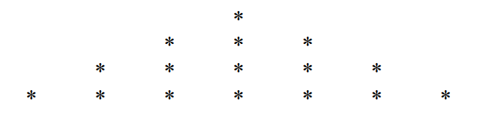
Source code :
<!doctype html>
<html lang="en">

<head>
<title>Lab Manual Program-2</title>
</head>

<body>
<h2>
<pre>
*
* * *
* * * * *
* * * * * * *
</pre>
</h2>
</body>
</html>

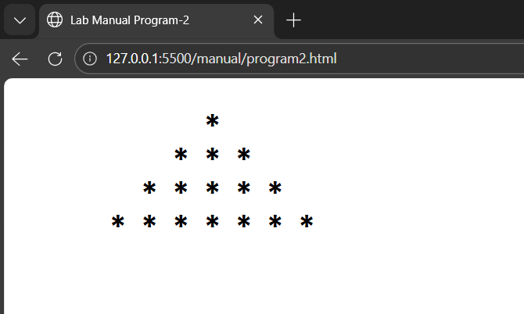
Output:

Program 3:
Create a web page to print the following table:
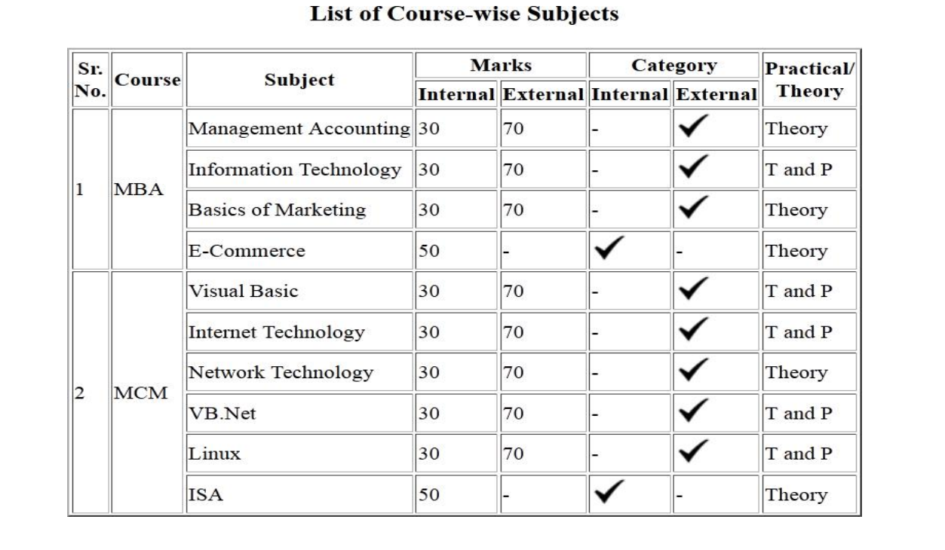
Source code :
<!DOCTYPE html>
<html>
<head>
<title>Lab Manual Program-3</title>
</head>
<body> <h2 align="center">List of Course-wise Subjects</h2>
<table border="1" cellspacing="0" cellpadding="8" align="center">
<tr>
<td rowspan="2">Sr. No.</td>
<td rowspan="2">Course</td>
<td rowspan="2">Subject</td>
<td colspan="2">Marks</td>
<td colspan="2">Category</td>
<td rowspan="2">Practical / Theory</td>
</tr>
<tr>
<td>Internal</td>
<td>External</td>
<td>Internal</td>
<td>External</td>
</tr>
<tr>
<td rowspan="4">1</td>
<td rowspan="4">MBA</td>
<td>Management Accounting</td>
<td>30</td>
<td>70</td>
<td>-</td>
<td>✔</td>
<td>Theory</td>
</tr>
<tr>
<td>Information Technology</td>
<td>30</td>
<td>70</td>
<td>-</td>
<td>✔</td>
<td>T and P</td>
</tr>
<tr>
<td>Basics of Marketing</td>
<td>30</td>
<td>70</td>
<td>-</td>
<td>✔</td>
<td>Theory</td>
</tr>
<tr>
<td>E-Commerce</td>
<td>50</td>
<td>-</td>
<td>✔</td>
<td>-</td>
<td>Theory</td>
</tr>
<tr>
<td rowspan="6">2</td>
<td rowspan="6">MCM</td>
<td>Visual Basic</td>
<td>30</td>
<td>70</td>
<td>-</td>
<td>✔</td>
<td>T and P</td>
</tr>
<tr>
<td>Internet Technology</td>
<td>30</td>
<td>70</td>
<td>-</td>
<td>✔</td>
<td>T and P</td>
</tr>
<tr>
<td>Network Technology</td>
<td>30</td>
<td>70</td>
<td>-</td>
<td>✔</td>
<td>Theory</td>
</tr>
<tr>
<td>VB.Net</td>
<td>30</td>
<td>70</td>
<td>-</td>
<td>✔</td>
<td>T and P</td>
</tr>
<tr>
<td>Linux</td>
<td>30</td>
<td>70</td>
<td>-</td>
<td>✔</td>
<td>T and P</td>
</tr>
<tr>
<td>ISA</td>
<td>50</td>
<td>-</td>
<td>✔</td>
<td>-</td>
<td>Theory</td>
</tr>
</table>
</body>
</html>
Output:

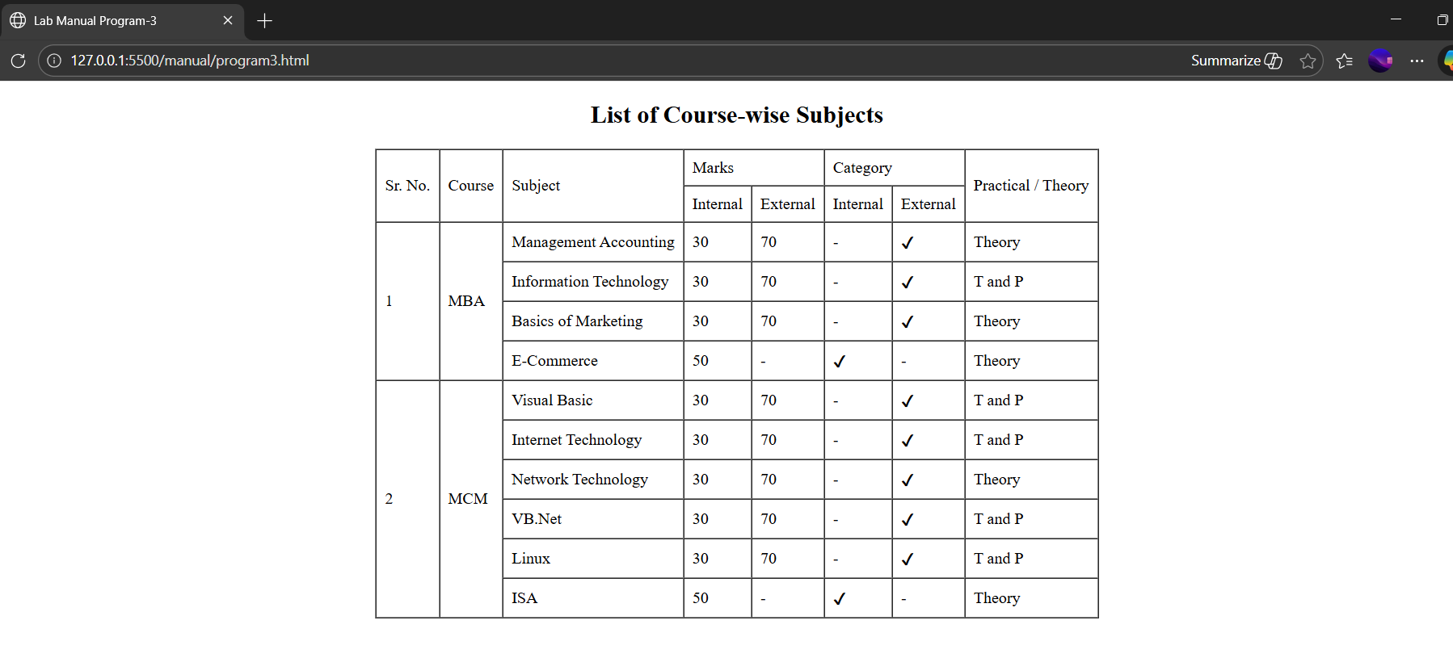
Program 4
Using table related tags align the images with hyperlinks.
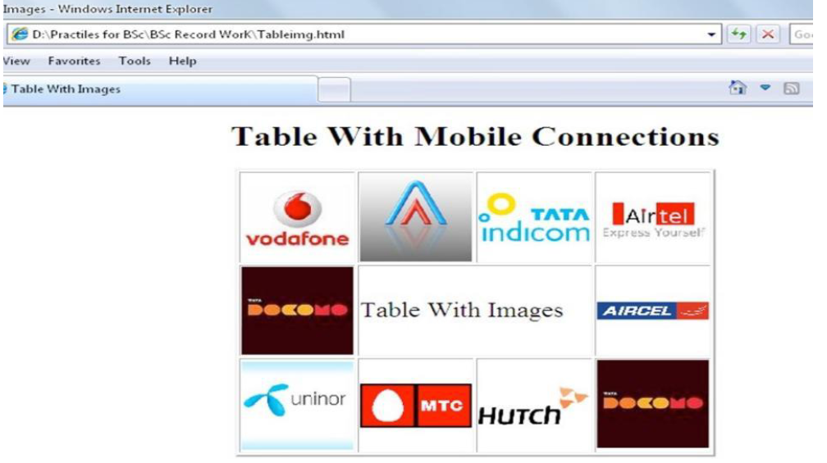
Source code :
<!DOCTYPE html>
<html>

<head>
<title>Lab Manual Program-4</title>
</head>

<body>
<h2 align="center">Table With Images</h2>
<table border="1" cellpadding="15" cellspacing="0" align="center">
<tr>
<td align="center">
<a href="https://www.myvi.in/" target="_blank">
<img src="/image/vodaphone.png" width="120">
</a>
</td>
<td align="center">
<a href="https://www.axis.com" target="_blank">
<img src="/image/axis.png" width="80">
</a>
</td>
<td align="center">
<a href="https://www.tata.com/business/tata-teleservices" target="_blank">
<img src="/image/indicom.jpg" width="80">
</a>
</td>
<td align="center">
<a href="https://www.airtel.in/" target="_blank">
<img src="/image/Airtel-logo.png" width="70">
</a>
</td>
</tr>
<tr>
<td align="center">
<a href="https://www.docomo.ne.jp/english/" target="_blank">
<img src="/image/docomo.png" width="120">
</a>
</td>
<td align="center" colspan="2">
<b>Table With Images</b>
</td>
<td align="center">
<a href="https://www.aircel.com/" target="_blank">
<img src="/image/aircel-logo.jpg" width="90">
</a>
</td>
</tr>
<tr>
<td align="center">
<a href="https://www.telenor.com/" target="_blank">
<img src="/image/Uninor.jpg" width="90">
</a>
</td>
<td align="center">
<a href="https://www.mtc.com.na/" target="_blank">
<img src="/image/mtc.jpg" width="100">
</a>
</td>
<td align="center">
<a href="http://hutch.lk/" target="_blank">
<img src="/image/hutch.gif" width="100">
</a>
</td>
<td align="center">
<a href="https://www.docomo.ne.jp/english/" target="_blank">
<img src="/image/docomo.png" width="100">
</a>
</td>
</tr>
</table>
</body>
</html>

Output:

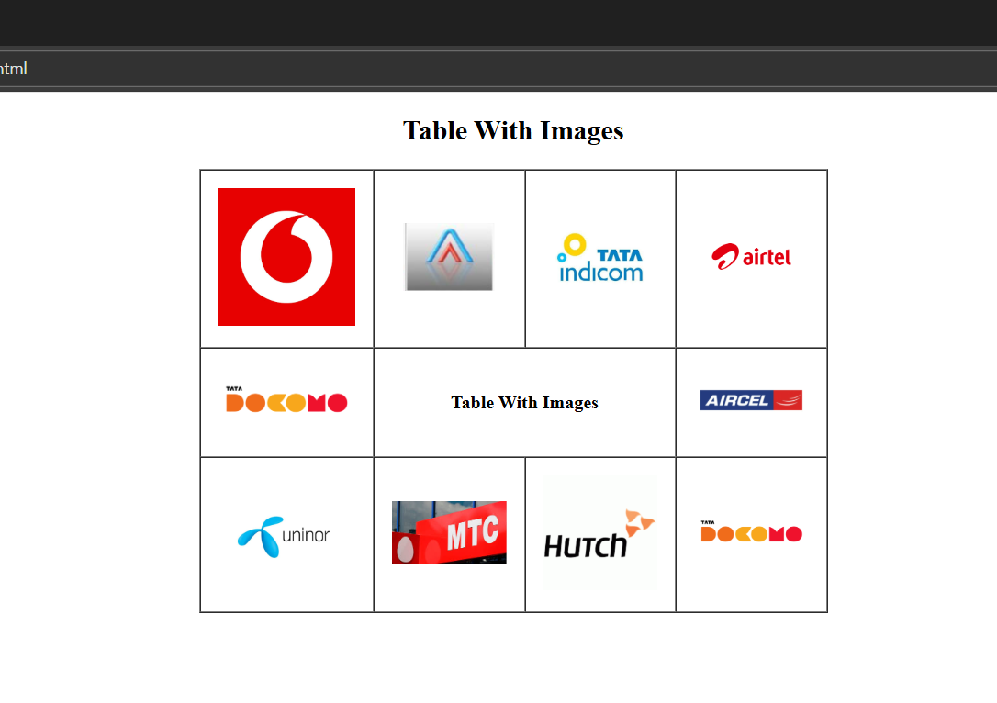
Program 5
Create a web page with the following using HTML:
- To embed an image map in a web page
- II. To fix the hot spots
- III. Show all the related information when the hot spots are clicked.
Source code :
<!DOCTYPE html>
<html lang="en">
<head>
<meta charset="UTF-8">
<title>Lab Manual Program-5 </title>
</head>
<body>
<h2>Image Map Using HTML</h2>
<img src="img1.png" usemap="#imagemap" width="400" height="300" alt="Image Map">
<map name="imagemap">
<area shape="rect" coords="0,0,400,75"
href="https://www.google.com" alt="Google">

<area shape="rect" coords="0,75,400,150"
href="https://www.youtube.com" alt="YouTube">

<area shape="rect" coords="0,150,400,225"
href="https://www.instagram.com" alt="Instagram">

<area shape="rect" coords="0,225,400,300"
href="https://www.facebook.com" alt="Facebook">
</map>
</body>
</html>
Output:
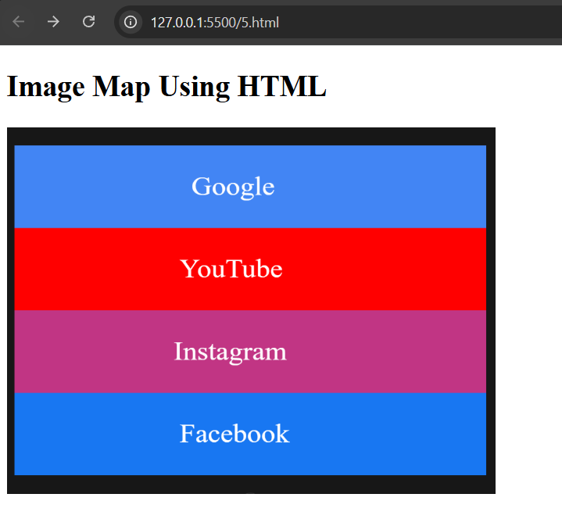

Program 6
Write a HTML code for the following snapshot.
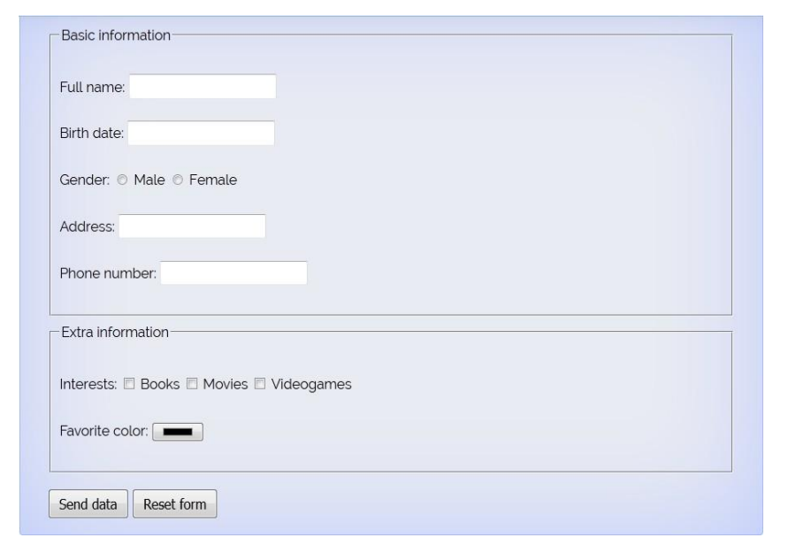
Source code :
<!DOCTYPE html>
<html lang="en">
<head>
<meta charset="UTF-8">
<title>Form Example</title>
</head>
<body bgcolor="#dbe7f6">
<form>
<fieldset>
<legend>Basic information</legend>
Full name:
<input type="text" name="fullname"><br><br>
Birth date:
<input type="date" name="birthdate"><br><br>
Gender:
<input type="radio" name="gender"> Male
<input type="radio" name="gender"> Female
<br><br>
Address:
<input type="text" name="address"><br><br>
Phone number:
<input type="tel" name="phone"><br><br>
</fieldset>
<br>
<fieldset>
<legend>Extra information</legend>
Interests:
<input type="checkbox"> Books
<input type="checkbox"> Movies
<input type="checkbox"> Videogames
<br><br>
Favorite color:
<input type="color">
<br><br>
</fieldset>
<br>
<input type="submit" value="Send data">
<input type="reset" value="Reset form">
</form>
</body>
</html>

</html>

Output:
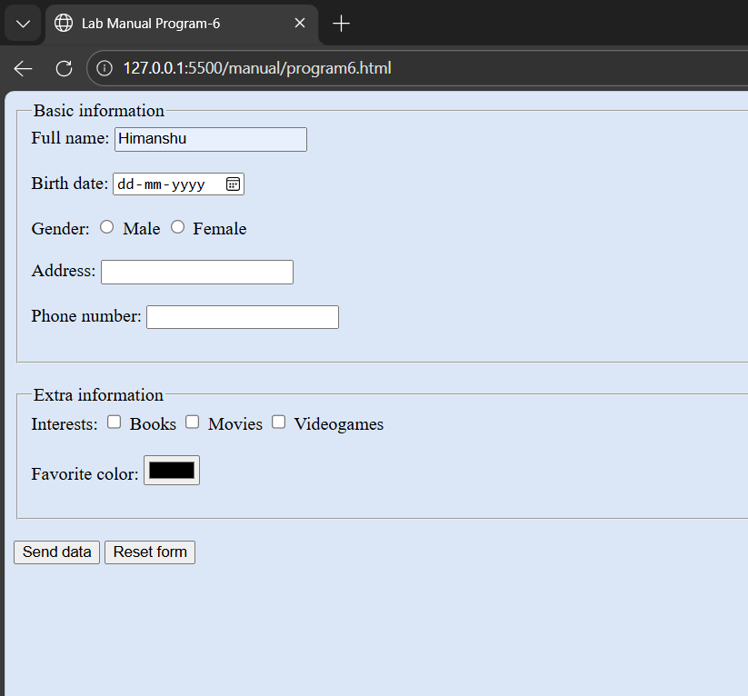
Program 7
Create a web page of customer profile for data entry of customer’s in a Hotel, The profile should include Name, Address, Age, gender, Room Type (A/C, Non-A/C or Deluxe), Type of payment (Cash, Credit/Debit Card or Coupons).
Source code :
<!DOCTYPE html>
<html>

<head>
<title>Lab Manual Program-7</title>
</head>

<body style="background-color:lightblue;">
<form>
<fieldset>
<legend>Basic Information</legend>
Full Name:
<input type="text" name="name"><br><br>
Age:
<input type="number" name="age"><br><br>
Gender:
<input type="radio" name="gender" value="Male"> Male
<input type="radio" name="gender" value="Female"> Female<br><br>
Address:
<input type="text" name="address"><br><br>
</fieldset>
<br>
<fieldset>
<legend>Room & Payment Information</legend>
Room Type:<br>
<input type="radio" name="room" value="AC"> A/C
<input type="radio" name="room" value="Non-AC"> Non-A/C
<input type="radio" name="room" value="Deluxe"> Deluxe<br><br>
Type of Payment:<br>
<input type="radio" name="payment" value="Cash"> Cash
<input type="radio" name="payment" value="Card"> Credit/Debit Card
<input type="radio" name="payment" value="Coupons"> Coupons<br><br>
</fieldset>
<br>
<input type="submit" value="Send Data">
<input type="reset" value="Reset Form">
</form>
</body>
</html>

Output:
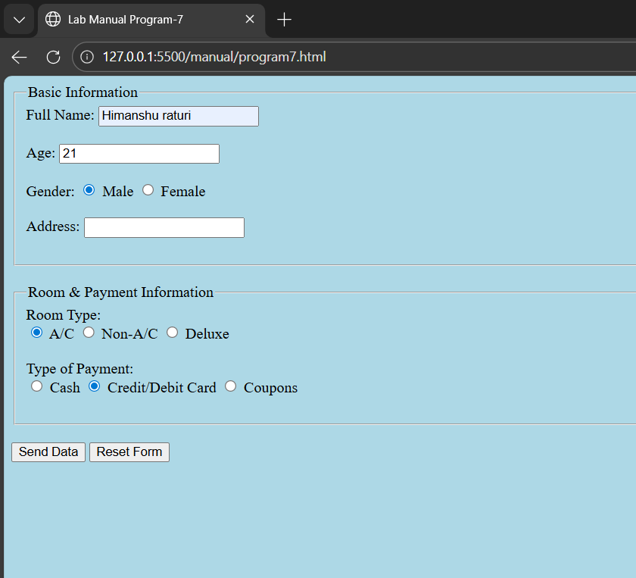
Program 8
Demonstrate the use of following HTML5 Tags:
I. <Video>
II. <Audio>
III. <Header>
IV. <Footer>
V. <Nav>
VI. <Embed>
VII. <Datalist>
VIII. <Bdi>
IX. <Article>
X. <Output>
Source code :
<!doctype html>
<html lang="en">
<head>
<title>Lab Manual Program-8</title>
</head>
<body>
<header>
<h1>This is Header.</h1>
</header>
<nav>
<a href="#" target="_blank">Home</a>
<a href="#" target="_blank">Projects</a>
<a href="#" target="_blank">Academic</a>
<a href="#" target="_blank">About Me</a>
</nav>
<h3>Video element</h3>
<video controls autoplay loop muted width="250"
src="/video/Detailed_Google_Cloud_Computing_Foundations_Summary[1].mp4" alt="Video here"></video>
<h3>Audio element</h3>
<audio controls autoplay loop muted src="/audio/1.mpeg"></audio>
<h3>Embed Element</h3>
<embed type="image/jpg" src="/image/axis.png" width="250" height="150"></embed>
<h3>Datalist Element</h3>
<form>
<label for="browser">Choose your browser from the list:</label>
<input list="browser" name="browser" id="datalist-tag">
<datalist id="browser">
<option value="Edge">
<option value="Firefox">
<option value="Google Chrome">
<option value="Opera">
<option value="Safari">
</datalist>
<input type="submit">
</form>
<h3>The bdi Element</h3>
<p>In the example below, usernames are shown along with the number of points in a contest. If the bdi element is not
supported in the browser, the username of the Arabic user would confuse the text (the bidirectional algorithm
would put the colon and the number "90" next to the word "User" rather than next to the word "points").</p>
<ul>
<li>User <bdi>hrefs</dbi>:60 points</li>
<li>User <bdi>jdoe</dbi>:80 points</li>
<li>User <bdi>إيان</dbi>:90 points</li>
</ul>
<h3>Article element</h3>
<article>
<h4>Google Chrome</h4>
<p>Google Chrome is a web browser developed by Google, released in 2008. Chrome is the world's most popular web
browser today!</p>
</article>
<article>
<h4>Mozilla Firefox</h4>
<p>Mozilla Firefox is an open-source web browser developed by Mozilla. Firefox has been the second most popular
web browser since January, 2018.</p>
</article>
<h3>Output Element</h3>
<form oninput="x.value=parseInt(a.value)+parseInt(b.value)">
<input type="range" id="a" value="50">
+<input type="number" id="b" value="25">
=<output name="x" for="a b"></output>
</form>
<footer>
&copy; All Right Reserved.
</footer>
</body>
</html>

Output:
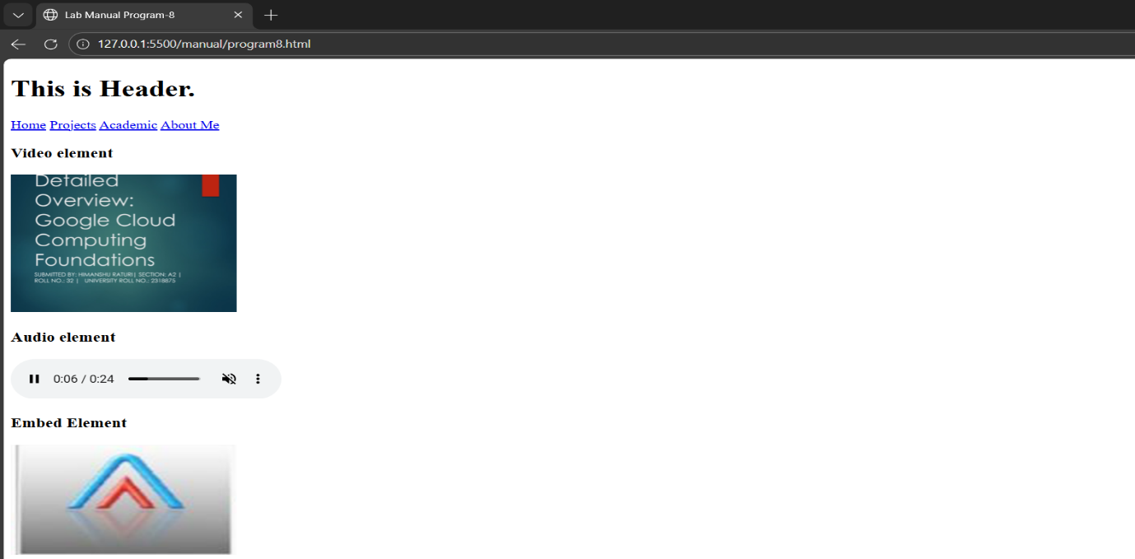
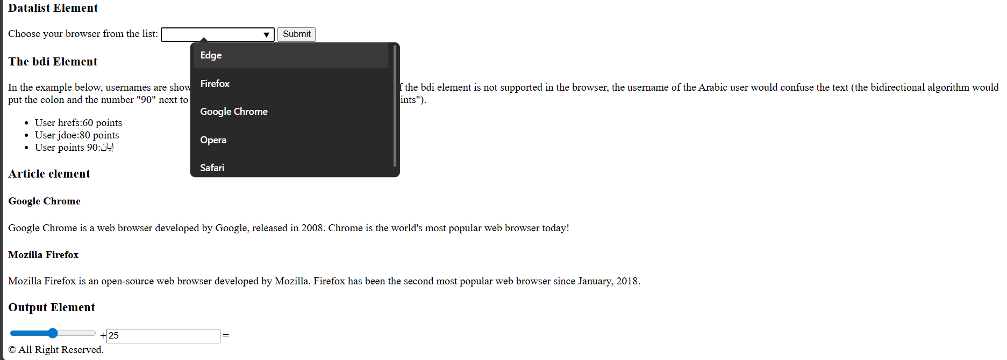
Program 9
Design an HTML page to create the following list.
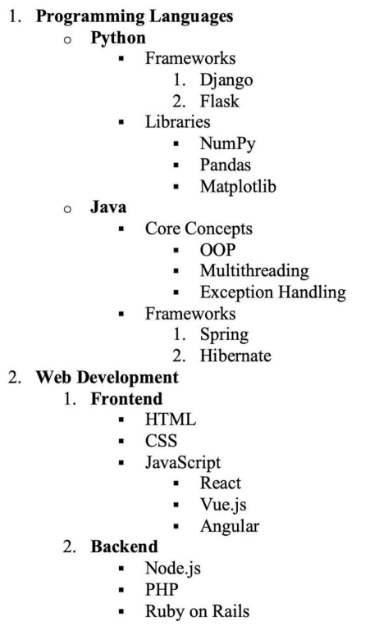
Source code :
<!doctype html>
<html lang="en">
<head>
<title>Lab Manual Program-9</title>
</head>
<body>
<ol>
<li><b>Programming Language</b></li>
<ul>
<li><b>Python</b></li>
<ul>
<li>Frameworks</li>
<ol>
<li>Django</li>
<li>Flask</li>
</ol>
<li>Libraries</li>
<ul>
<li>NumPy</li>
<li>Pandas</li>
<li>Matplotlib</li>
</ul>
</ul>
<li><b>Java</b></li>
<ul>
<li>Core concepts</li>
<ul>
<li>OOP</li>
<li>Multithreading</li>
<li>Exception Handling</li>
</ul>
<li>Frameworks</li>
<ol>
<li>Spring</li>
<li>Hibernate</li>
</ol>
</ul>
</ul>
<li><b>Web Development</b></li>
<ol>
<li><b>Frontend</b></li>
<ul>
<li>HTML</li>
<li>CSS</li>
<li>JavaScript</li>
<ul>
<li>React</li>
<li>Vue.js</li>
<li>Angular</li>
</ul>
</ul>
<li><b>Backend</b></li>
<ul>
<li>Node.js</li>
<li>PHP</li>
<li>Ruby on Rails</li>
</ul>
</ol>
</ol>
</body>
</html>

Output:
